
American International University- Bangladesh (AIUB) Faculty of Engineering (FE)

Course Name: | DATA COMMUNICATION | Course Code: | COE3103
Semester: | Spring 2024-25 | Section: | L
Faculty: | DR. AMIRUL ISLAM | Group: | 08
Experiment No: | 01
Experiment Name: | Introduction to MATLAB

Submitted by (NAME): | MOHSIN IBNA HOSSAIN | Student ID: | 23-50194-1
Group Members |  | Name | ID
 | 1. | MD. MIRAN HOSSAIN | 22-46175-1
 | 2. | FAHMIDA RAHMAN | 22-48483-3
 | 3. | MOHSIN IBNA HOSSAIN | 23-50194-1
 | 4. | MD. YEAHYEA JAM | 23-50187-1
 | 5. | HOSSAIN MOHAMMAD SAMI | 23-51354-1

Performance Date: | 10/03/2025 | Due Date: | 17/03/2025
Marking Rubrics (to be filled by Lab Instructor)
Category | Proficient [6] | Good [4] | Acceptable [2] | Unacceptable [1] | Secured Marks
Theoretical Background, Methods & procedures sections | All information, measures and variables are provided and  explained. | All Information provided is sufficient, but more explanation is  needed. | Most information is correct, but some information may be  missing or inaccurate. | Much information is missing and/or inaccurate.
Results | All of the criteria are met; results are described clearly and accurately; | Most criteria are met, but there may be some lack of clarity and/or incorrect information. | Experimental results don’t match exactly with the theoretical values and/or analysis  is unclear. | Experimental results are missing or incorrect;
Discussion | Demonstrates thorough and sophisticated understanding.  Conclusions drawn are appropriate for  analyses; | Hypotheses are clearly stated, but some concluding statements not supported by data or data not well  integrated. | Some hypotheses missing or misstated; conclusions not supported by data. | Conclusions don’t match hypotheses, not supported by data; no integration of data from different sources.
General formatting | Title page, placement of figures and figure captions, and other  formatting issues all correct. | Minor errors in formatting. | Major errors and/or missing information. | Not proper style in text.
Writing & organization | Writing is strong and easy to understand; ideas are fully elaborated and connected; effective transitions between sentences; no  typographic, spelling, or grammatical errors. | Writing is clear and easy to understand; ideas are connected; effective transitions between sentences; minor typographic, spelling, or grammatical errors. | Most of the required criteria are met, but some lack of clarity, typographic, spelling, or grammatical errors are present. | Very unclear, many errors.
Comments: |  |  |  | Total Marks (Out of 30):

Title
Introduction to MATLAB
Abstract
This experiment is designed to-
1.To understand the use of MATLAB for solving communication engineering problems.
2.To develop understanding of MATLAB environment, commands and syntax.
Introduction
MATLAB (Matrix Laboratory) is a high-performance programming language specifically designed for technical computing. It provides an interactive environment that integrates computation, programming, and visualization, enabling users to solve engineering and scientific problems efficiently. MATLAB is widely used in communication engineering due to its powerful built-in mathematical functions, extensive toolboxes, and user-friendly syntax.
Unlike traditional programming languages such as C or Fortran, MATLAB operates with arrays as its fundamental data structure, eliminating the need for explicit dimensioning. This feature simplifies matrix and vector operations, allowing users to perform complex calculations with minimal coding effort. MATLAB supports a variety of numerical methods, including arithmetic and logical operations, mathematical functions, graphical visualization, and input/output operations.
One of the key features of MATLAB is its toolbox functionality. Toolboxes extend MATLAB's capabilities by providing specialized functions for different applications, such as signal processing, image processing, and communications. These toolboxes help engineers and researchers develop efficient solutions tailored to their specific fields.
MATLAB also facilitates visualization through its advanced plotting functions. Users can create 2D and 3D plots, customize graphical representations, and analyze data effectively. MATLAB offers powerful tools such as Creating a Plot and Creating Subplots, allowing users to visualize multiple functions in a single window. The Controlling Axes feature enables users to define custom axis limits and scaling, improving the clarity of graphical outputs.
Matrix manipulation is a crucial part of MATLAB, as it supports Generating Matrices using built-in functions like zeros, ones, rand, and randn. Users can also utilize the linspace function, which generates linearly spaced vectors, using the format linspace(first value, last value, number of values). Additionally, MATLAB allows for Deleting Rows and Columns, providing flexibility in modifying data structures.
This experiment aims to introduce students to the MATLAB environment, familiarize them with fundamental MATLAB commands, and demonstrate its application in solving communication engineering problems. By gaining hands-on experience with MATLAB, students will develop a solid foundation in computational techniques essential for data communication and signal processing.
Results and Discussion
(a) Plot two curves on a single graph, assigning distinct labels for the title, x-axis, and y-axis. Additionally, specify unique colors, line styles, and markers for each curve. Use the axis command to customize the axis limits and scaling as needed.
Code:
clc;
clear;

a1 = 10;
a2 = 6;
f1 = 2;
f2 = 6;
t = 0:0.01:1;

s1 = a1 * cos(2 * pi * f1 * t);
s2 = a2 * sin(2 * pi * f2 * t);

figure;

plot(t, s1, 'c--o', 'LineWidth', 2, 'MarkerSize', 3);
hold on;
plot(t, s2, 'm-.*', 'LineWidth', 2, 'MarkerSize', 3);

title('Comparison of Signals s1 and s2');
xlabel('Time (seconds)');
ylabel('Amplitude');

axis([0 1 -15 15]);
grid on;

Result and Discussion:
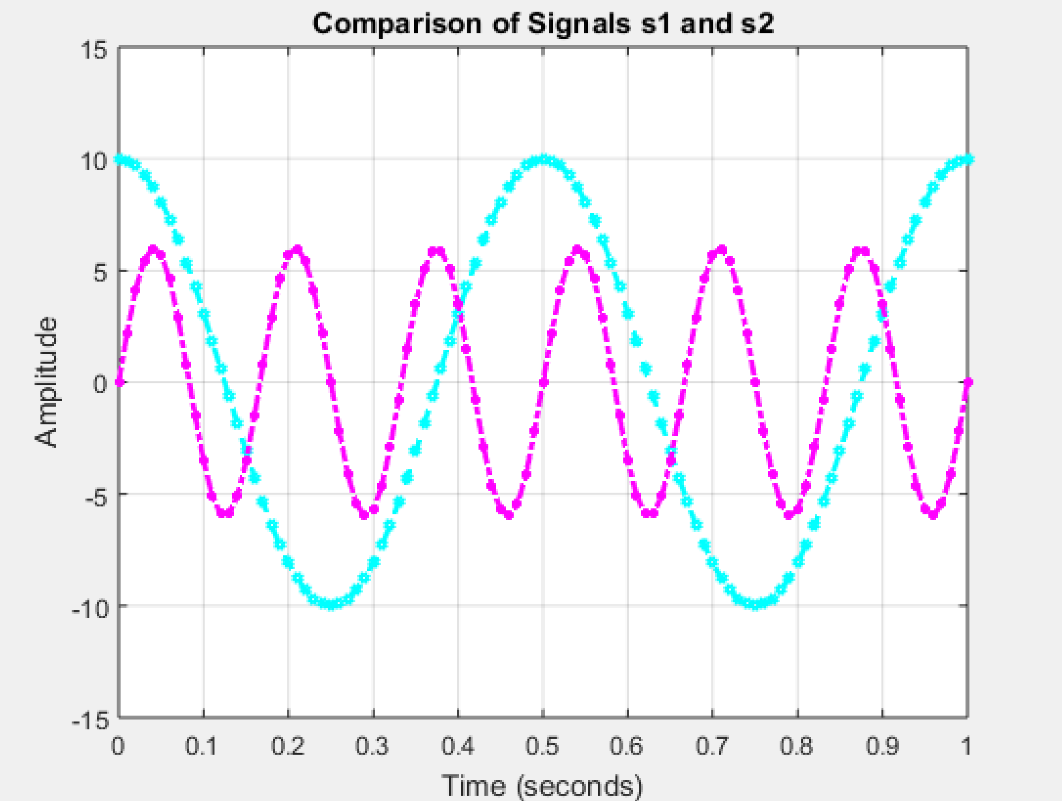
Fig1: Comparison of signals s1 and s2
- Two sinusoidal signals, s1(t) and s2(t) were generated using cosine and sine functions, respectively.
- The plot function was used to represent both signals on the same graph with distinct line styles, markers, and colors.
- The axis function was implemented to set appropriate axis limits, ensuring clarity in visualization.

(b) Print a text inside the plot “This is a test plot of Experiment 1 of Name and ID”
Code:
clc;
clear;

a1 = 10;
a2 = 6;
f1 = 2;
f2 = 6;
t = 0:0.01:1;

s1 = a1 * cos(2 * pi * f1 * t);
s2 = a2 * sin(2 * pi * f2 * t);

figure;
plot(t, s1, 'c--o', 'LineWidth', 2, 'MarkerSize', 3);
hold on;
plot(t, s2, 'm-.*', 'LineWidth', 2, 'MarkerSize', 3);

title('Comparison of Signals s1 and s2');
xlabel('Time (seconds)');
ylabel('Amplitude');
axis([0 1 -15 15]);
grid on;

text(0.5, 12, 'This is a test plot of Experiment 1 of Mohsin Ibna Hossain, ID: 23-50194-1', ...
'HorizontalAlignment', 'center', 'VerticalAlignment', 'top', 'FontSize', 8, 'FontWeight', 'bold', 'Color', 'black');

Result and Discussion:
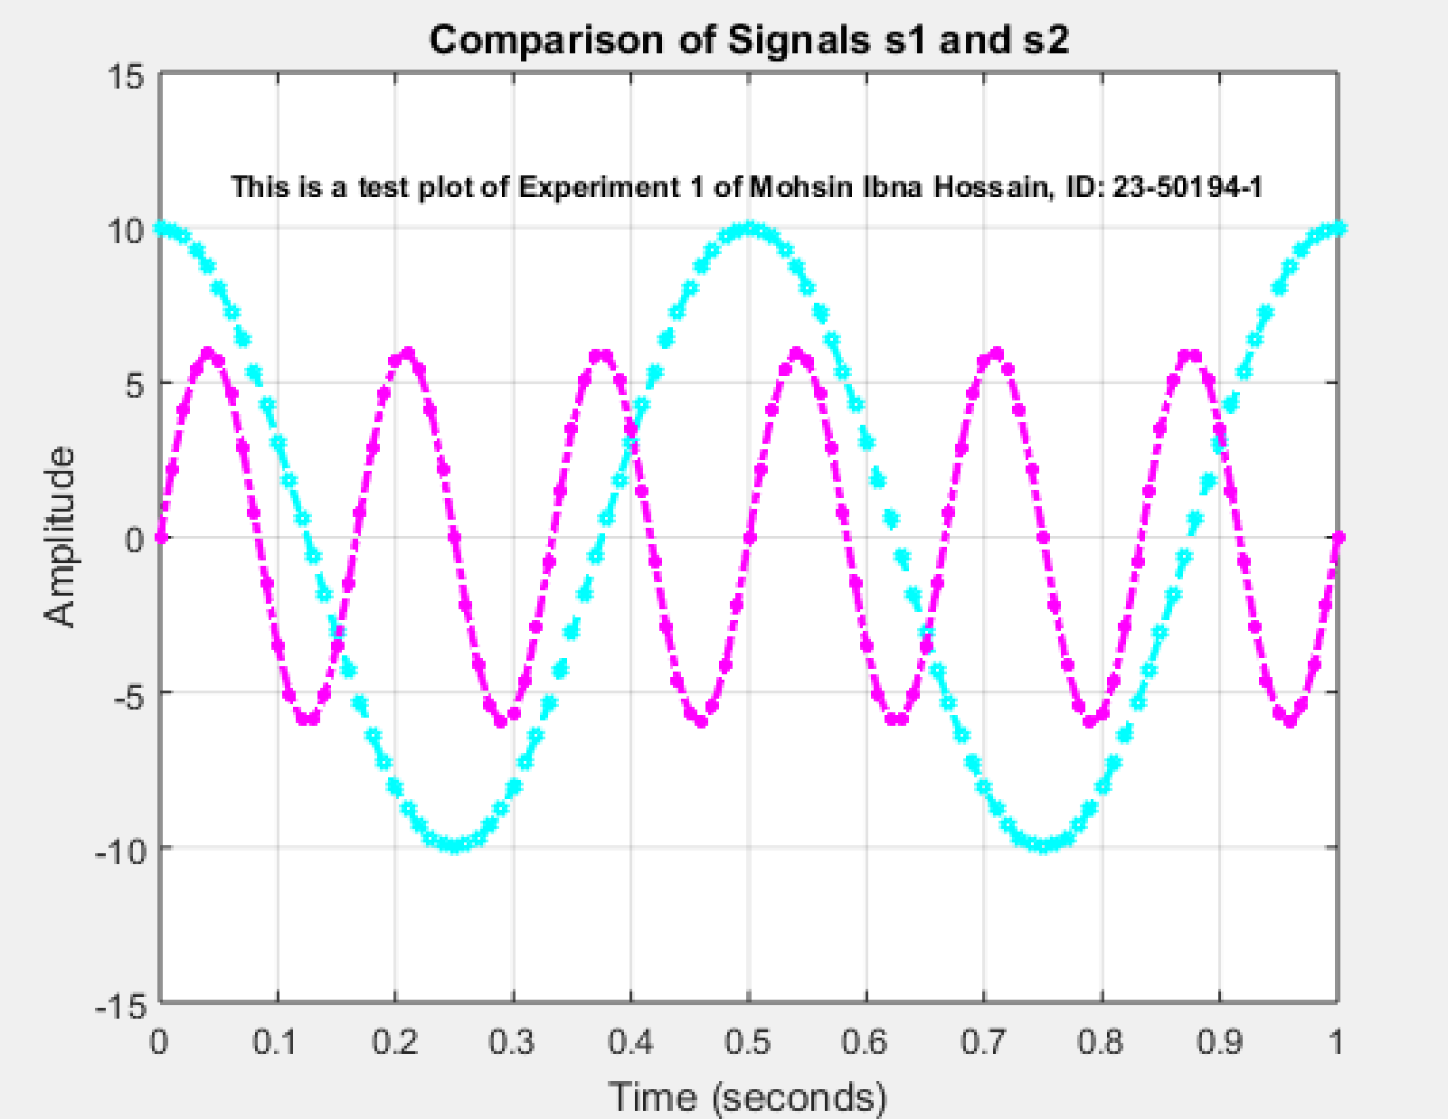
Fig2: Print a text inside the plot
• Titles, axis labels, and grid lines were included to enhance readability and comprehension of the plots.
• A text annotation was inserted within the graph to provide contextual information, demonstrating MATLAB's capability in labeling and customizing plots.

(c) Use subplot(3,1,1) and subplot(3,1,2) to make a three-panel subplot that puts both of these plots on the same window. See help subplot if needed

Code:
clc;
clear;
a1 = 10;
a2 = 6;
f1 = 2;
f2 = 6;

t = 0:0.01:1;

s1 = a1 * cos(2 * pi * f1 * t);
s2 = a2 * sin(2 * pi * f2 * t);
figure;
subplot(3, 1, 1);
plot(t, s1, 'c--o', 'LineWidth', 1, 'MarkerSize', 3);

title('Comparison of Signals s1');
xlabel('Time (seconds)');
ylabel('Amplitude');

axis([0 1 -15 15]);
grid on;
text(0.5, 12, 'This is a test plot of Experiment 1 of Mohsin Ibna Hossain, ID: 23-50194-1', ...
'HorizontalAlignment', 'center', 'VerticalAlignment', 'top', 'FontSize', 8, 'FontWeight', 'bold', 'Color', 'black');

subplot(3, 1, 2);
plot(t, s2, 'm-.*', 'LineWidth', 1, 'MarkerSize', 3);
title('Comparison of Signals s2 ');
xlabel('Time (seconds)');
ylabel('Amplitude');

axis([0 1 -15 15]);
grid on;
text(0.5, 12, 'This is a test plot of Experiment 1 of Mohsin Ibna Hossain, ID: 23-50194-1', ...
'HorizontalAlignment', 'center', 'VerticalAlignment', 'top', 'FontSize', 8, 'FontWeight', 'bold', 'Color', 'black');

Result and Discussion:
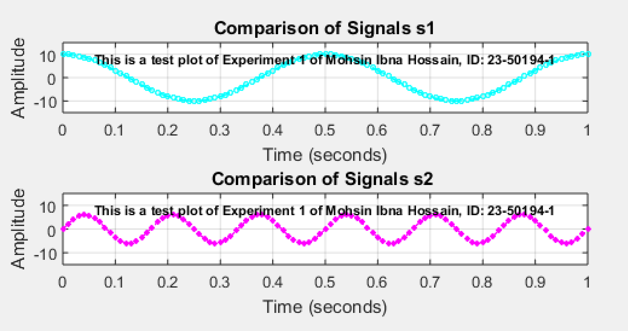
Fig3: Print panel subplot
• The subplot function was used to organize multiple plots in a single figure window.
• Three panels were created: the first two displaying individual signals and the third showing their sum.
• This method is particularly useful for comparing signals within a single visual framework.

(d) Create a third sinusoid as the sum: s3(t) = s1(t) + s2(t). In Matlab this amounts to summing the vectors that hold the samples of each sinusoid. Make a plot of s3 (t) over the same range of time as used in the previous two plots. Include this as the third panel in the window by using subplot (3,1,3).

Code:
clc;
clear;

a1 = 10;
a2 = 6;
f1 = 2;
f2 = 6;

t = 0:0.01:1;

s1 = a1 * cos(2 * pi * f1 * t);
s2 = a2 * sin(2 * pi * f2 * t);
s3= s1+s2;
figure;

subplot(3, 1, 1);
plot(t, s1, 'c--o', 'LineWidth', 1, 'MarkerSize', 3);
hold on;

title('Comparison of Signals s1');
xlabel('Time (seconds)');
ylabel('Amplitude');

axis([0 1 -15 15]);
grid on;
text(0.5, 12, 'This is a test plot of Experiment 1 of Mohsin Ibna Hossain, ID: 23-50194-1', ...
'HorizontalAlignment', 'center', 'VerticalAlignment', 'top', 'FontSize', 8, 'FontWeight', 'bold', 'Color', 'black');

subplot(3, 1, 2);

plot(t, s2, 'm-.*', 'LineWidth', 1, 'MarkerSize', 3);
title('Comparison of Signals s2');
xlabel('Time (seconds)');
ylabel('Amplitude');

axis([0 1 -15 15]);
grid on;
text(0.5, 12, 'This is a test plot of Experiment 1 of Mohsin Ibna Hossain, ID: 23-50194-1', ...
'HorizontalAlignment', 'center', 'VerticalAlignment', 'top', 'FontSize', 8, 'FontWeight', 'bold', 'Color', 'black');

subplot(3, 1, 3);
plot(t, s3, 'b-', 'LineWidth', 2, 'MarkerSize', 3);
hold on;
title('Comparison of Signals s3');
xlabel('Time (seconds)');
ylabel('Amplitude');

axis([0 1 -15 15]);
grid on;
text(0.5, 12, 'This is a test plot of Experiment 1 of Mohsin Ibna Hossain, ID: 23-50194-1', ...
'HorizontalAlignment', 'center', 'VerticalAlignment', 'top', 'FontSize', 8, 'FontWeight', 'bold', 'Color', 'black');

Result and Discussion:
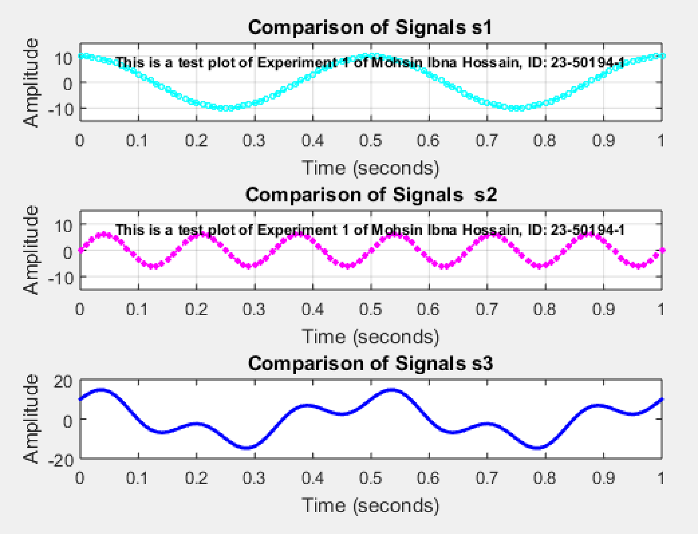
Fig4: Print a third sinusoid as the sum: s3(t) = s1(t) + s2(t).
• A third sinusoidal signal, s3(t) was created by summing s1(t) and s2(t).
• The resultant waveform was plotted to observe constructive and destructive interference between the original signals.

Conclusion
The experiment successfully demonstrated the basic functionalities of MATLAB in technical computing and data visualization. By plotting and analyzing sinusoidal signals, we gained practical experience in MATLAB’s fundamental operations, including matrix manipulations, function evaluations, and graphical representations. The ability to create and modify plots using plot, subplot, axis, and annotation functions provided insights into MATLAB’s effectiveness in engineering applications. The knowledge acquired from this experiment is essential for advanced signal processing and communication system analysis. Future improvements could involve exploring more complex signal transformations and frequency domain analysis using MATLAB’s built-in toolboxes.

